Punching Teminal PT S4 from Rittal Automation Systems
Rittal and Eplan at the 2024 SPS
12 to 14 November in Nuremberg
Hall 3C, Booth 321
Automated busbar machining – now also for smaller companies
Herborn, 2024-11-14
Getting started with automated busbar machining is often a significant hurdle for smaller switchgear manufacturers. The new Punching Terminal PT S4 from Rittal Automation Systems makes it easy to get started. It already becomes attractive when machining smaller quantities of copper every year. Despite its compact design, the new machine offers three interchangeable tools and another for cutting busbars to length, as well as a connection to the RiPanel Processing Center for digitised order processing. Another advantage for the user is the coordinated, consistent interaction Eplan planning and design tools across the value chain of plant engineering, from planning to the operation of machinery.
Busbars are a major growth market, and multiple factors ensure a constantly growing demand: The increasing importance of electrical energy in every area, from directly generated electrical energy in solar and wind power plants to e-mobility. Digitisation itself also consumes a significant amount of energy because of the increasing number of data centres, including larger ones. Moreover, significant economies such as the USA have altered their technical regulations, which means a changeover from cables to busbars in all types of enclosures.

The ever-increasing energy flows that must be distributed means that more busbars are needed. The new Punching Terminal PT S4 now also offers smaller switchgear manufacturers the chance to enter this future market, become independent of suppliers and increase their customer base.

Machining of copper and aluminium
The basic version of the Punching Terminal PT S4 processes flat copper, but the system can also be designed to process aluminium if needed. The PT S4 processes bars with a thickness of 3 to 16 millimetres and a width of 15 to 127 millimetres.

Four tool stations are installed to fit standard tools with a quick-change system, including a separation unit. Thanks to the strong tool springs and the resulting high retraction forces, even thick copper bars can be punched extremely cleanly so that no reworking is needed.
Digitisation for efficient punching
The interaction of Eplan engineering tools across the value chain, from planning to machine operation, is particularly beneficial. The Punching Terminal PT S4 is supplied with data from the digital software solutions from Eplan, such as the Eplan Pro Panel with the Eplan Copper module or other applications. The machining centre reads the geometry and then independently punches the holes and recesses desired into the blanks supplied. The system can also be integrated into the Rittal RiPanel Processing Center software. Then, orders and processes can be automatically distributed and digitally monitored. Furthermore, the networking of punching and bending machines with a shared database enables work on multiple machines. Programming can be performed directly on the machine and from the office workstation.

With the Punching Terminal PT S4, Rittal Automation Systems also offers smaller companies working with just a few tonnes of copper busbars a year the chance to get involved in automated busbar processing. In such applications, the new, compact machine will pay for itself in two to three years.

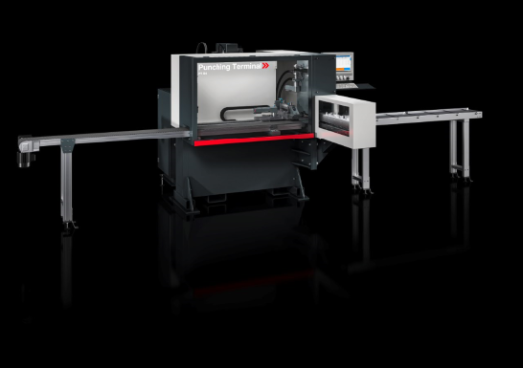
Caption
Getting started with automated busbar machining is often a significant hurdle for smaller switchgear manufacturers. The new Punching Terminal PT S4 from Rittal Automation Systems makes it easy to get started. It already becomes attractive when machining smaller quantities of copper every year.

Abdruck honorarfrei. Bitte geben Sie als Quelle Rittal GmbH & Co. KG an.
Rittal

Rittal is a leading global supplier of enclosure systems, automation and infrastructure with its industrial, IT, energy and power, cooling and service units. Rittal products and solutions are used in over 90% of global industries – standardised, customised, and always of the very best quality.
Our approach and methodology: With their combined hardware and software expertise, Rittal, Rittal Software Systems (Eplan and Cideon) and Rittal Automation Systems (RAS, Ehrt, Alfra) optimize, digitize and automate processes along the entire customer value chain, including the IT infrastructure – from panel building and switchgear manufacturing to mechanical engineering, factory operators and the energy sector.
Our delivery promise: Rittal standard products are delivered in Germany within 24 hours, and within 48 hours throughout Europe.
Customer focus
Improving efficiency and increasing productivity through automation and digitalisation is one of the biggest challenges for our customers. This requires in-depth knowledge and expertise, the combination of hardware and software, and cross-sector networking. We are convinced that creating and connecting data rooms is crucial to the success of industrial transformation. And that is exactly our speciality and field of competence.
Eplan and Rittal are driving the development of the digital automation twin, making data accessible and useable in operations as well. Cideon is improving data consistency in the digital product twin context with its CAD/CAM, PDM/PLM and product configuration expertise.
Sustainability
Environmental and climate protection, social commitment and ethical corporate management are a given for Rittal. We take our responsibility for a sustainable future seriously. Our approach to resource management and conservation involves continuous improvement of our own production processes and ensuring that our products have the lowest possible Product Carbon Footprint. Our solutions support our customers in achieving their own climate targets.
Family business and global player
Founded in 1961, Rittal is the largest company in the owner-operated Friedhelm Loh Group. The group operates worldwide, with 12 production sites and 95 international subsidiaries. It has 12,100 employees and posted revenues of 3 billion euros in fiscal 2023. In 2023, the Friedhelm Loh Group was presented with the “Best Place to Learn” and “Employer of the Future” awards. In 2024, Rittal was awarded the Top 100 Seal as one of Germany’s most innovative medium-sized companies for the third time in a row.
For more information, visit www.rittal.com and www.friedhelm-loh-group.com.

Corporate Communications
Dr. Carola Hilbrand Rittal GmbH & Co. KG
Corporate & Brand Communications Auf dem Stützelberg
Phone: 02772/505-2527 35745 Herborn
hilbrand.c@rittal.de www.rittal.com


Follow us:

